Day 394 — Advanced ML Revision
Complete Revision Notes | Preprocessing Pipelines • Feature Engineering • Advanced CV • Hyperparameter Tuning • Bias-Variance • Interpretability
Learning goal: master advanced machine learning engineering: construct leak-free Scikit-Learn Preprocessing Pipelines and ColumnTransformers, engineer high-signal features (polynomial, binning, target encoding), implement robust Cross-Validation strategies (Nested CV, Stratified, Group, TimeSeries), execute hyperparameter optimization (Grid, Random, Bayesian Optimization), navigate the Bias-Variance tradeoff and Regularization (L1, L2, ElasticNet), evaluate feature importances (MDI, Permutation, SHAP), and benchmark multiple candidate models.

1. Production Preprocessing Pipelines & Preventing Data Leakage
In enterprise machine learning, model training represents only a small component of the total system architecture. Raw data invariably arrives with missing values, heterogeneous data types, skewed distributions, and categorical strings.
Scikit-Learn's Pipeline and ColumnTransformer encapsulate the entire chain of feature transformations and model estimators into a single atomic object, ensuring that feature statistics (such as mean, median, min/max, or one-hot categories) are learned strictly from the training data and never leak from validation or test folds.
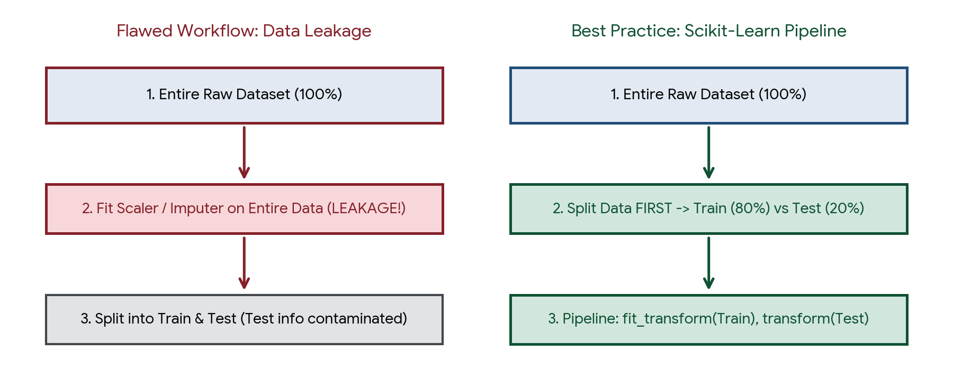
Figure 1. Architectural comparison: Flawed workflow inducing data leakage (left) versus atomic Pipeline execution (right).
Pipeline Component | Class / Interface | Primary Function | Key Method Execution
Transformer | StandardScaler, SimpleImputer, OneHotEncoder | Learns parameters from data and transforms feature representations | fit() learns parameters; transform() applies transformation
ColumnTransformer | sklearn.compose.ColumnTransformer | Applies distinct transformers to specified subsets of columns (numeric vs categorical) | Parallel execution across column selectors followed by concatenation
Pipeline | sklearn.pipeline.Pipeline | Chains sequential transformers followed by a final optional estimator | Calls fit_transform() on intermediate steps and fit() / predict() on final step
FeatureUnion | sklearn.pipeline.FeatureUnion | Concatenates outputs of multiple transformers evaluated in parallel on the same columns | Merges disparate extracted feature spaces horizontally

2. Advanced Feature Engineering Techniques
Feature engineering transforms raw attributes into high-signal representations that better expose the underlying data geometry to machine learning algorithms. While deep neural networks attempt to learn representations automatically, tabular machine learning (e.g., XGBoost, LightGBM) relies heavily on thoughtful feature construction.
Engineering Domain | Technique | Mathematical / Logical Operation | Machine Learning Impact
Numerical Transformations | Log / Box-Cox / Yeo-Johnson | y = ln(1 + x) or (x^λ − 1) / λ | Symmetrizes right-skewed features, compresses heavy tails, stabilizes variance
Interaction & Polynomials | PolynomialFeatures(degree=2, interaction_only=True) | x_new = x_i × x_j | Enables linear models to capture non-linear multiplicative dependencies
Discretization / Binning | KBinsDiscretizer / pd.qcut | Converts continuous variable into discrete ordinal intervals | Filters out high-frequency noise and captures non-monotonic thresholds
Categorical Encoding | Target / Mean Encoding with Smoothing | S_i = (n_c × ȳ_c + m × ȳ_global) / (n_c + m) | Encodes high-cardinality nominals into a single scalar without dimensionality explosion
Temporal Decomposition | Cyclical Sine / Cosine Encoding | x_sin = sin(2π t / T), x_cos = cos(2π t / T) | Preserves periodic continuity (e.g., hour 23 is immediately adjacent to hour 0)

Target Encoding & Preventing Severe Target Leakage
Target encoding replaces each category with the average target value for that category. If computed naively on the entire dataset, it causes extreme target leakage and catastrophic overfitting.
Target Encoding with M-Estimate Smoothing:

n_c * ȳ_c + m * ȳ_global
Encoded_c = --------------------------
n_c + m

Where:
- n_c = Number of observations in category c
- ȳ_c = Mean of target variable for category c
- ȳ_global = Global mean of target variable across entire training set
- m = Smoothing weight parameter (higher m shrinks small categories toward global mean)

Critical Guardrail: In Scikit-Learn (TargetEncoder), target encoding applies an internal
cross-fitting split (cv=5) on the training set so that a sample's own target value never
influences its own assigned categorical code!

3. The Bias-Variance Tradeoff & Model Generalization
The primary challenge in machine learning is achieving generalization: minimizing expected prediction error on novel, unseen data. The total expected generalization error of any supervised model decomposes mathematically into three distinct components.
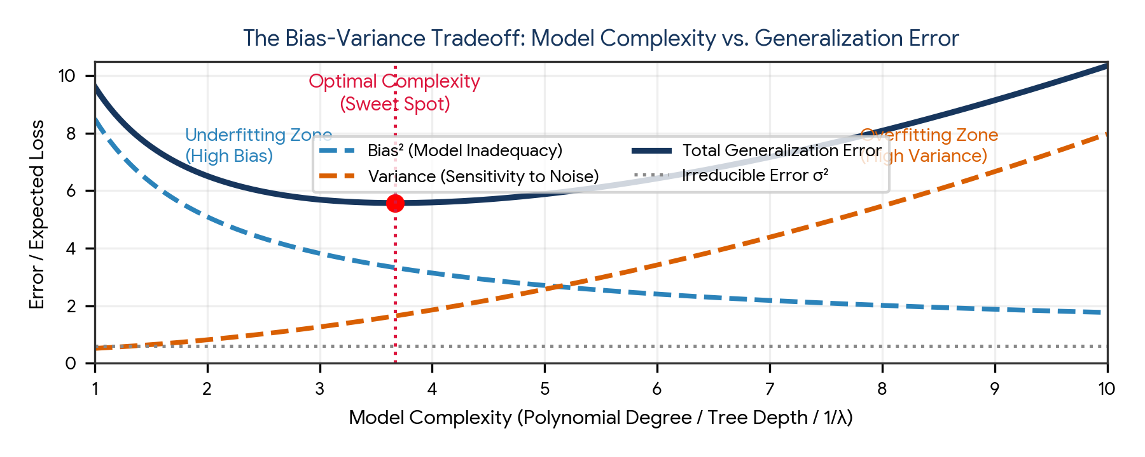
Figure 2. The Bias-Variance Tradeoff: Bias squared decreases with model complexity while Variance increases, identifying an optimal error minimum.
Error Component | Theoretical Definition | Root Cause | Diagnostic Symptom | Remediation Strategy
Bias² (Model Inadequacy) | ( E[f̂(x)] − f(x) )² | Overly restrictive hypothesis assumptions (underfitting) | High training error AND high validation error | Increase model complexity (e.g., deeper trees, polynomial terms), add informative features, reduce regularization
Variance (Sensitivity to Noise) | E[ (f̂(x) − E[f̂(x)])² ] | Excessive model flexibility memorizing training noise (overfitting) | Very low training error BUT high validation error | Collect more training data, apply L1/L2 regularization, prune trees, use ensemble bagging (Random Forest)
Irreducible Error (σ²) | Var(ε) | Inherent noise in data generation, measurement errors, or unobserved confounders | Error floor that cannot be eliminated by any algorithm | Improve sensor precision, engineer higher-quality features, eliminate label noise

4. Regularization Mechanics: L1, L2, and ElasticNet
Regularization introduces a penalty constraint on model complexity into the loss function, intentionally introducing a small amount of bias to achieve a substantial reduction in variance.
Regularization Technique | Mathematical Loss Function | Geometric Constraint | Coefficient Behavior | Primary Use Case
L2 Regularization (Ridge / Weight Decay) | J(w) = Loss_OLS + λ Σ [j=1 to d] w_j² | Smooth spherical L2 ball: ||w||₂² ≤ t | Shrinks weights continuously toward zero; never sets them exactly to zero | Mitigating multicollinearity, stabilizing large weights, dense feature retention
L1 Regularization (Lasso) | J(w) = Loss_OLS + λ Σ [j=1 to d] |w_j| | Sharp diamond polyhedron with axis corners: ||w||₁ ≤ t | Drives uninformative weights strictly to zero (sparse solutions) | High-dimensional feature selection, creating lightweight explainable models
ElasticNet Regularization | J(w) = Loss_OLS + α [ r Σ |w_j| + ((1−r)/2) Σ w_j² ] | Rounded diamond combining L1 corners and L2 curvature | Selects groups of correlated features while driving irrelevant features to zero | High-dimensional datasets where multiple features are mutually correlated (d >> n)

Why Feature Scaling is Absolutely Mandatory Prior to Regularization
Regularization penalties (λ Σ w_j² or λ Σ |w_j|) penalize all weights uniformly without regard to the original feature scale. If Feature A has a range of [0, 1] and Feature B has a range of [0, 100,000], Feature B's learned weight will naturally be tiny, allowing it to escape regularization penalties unfairly while Feature A is penalized severely. Therefore, StandardScaler must always precede regularized models.

5. Advanced Cross-Validation Architectures
Cross-validation evaluates how well an algorithm generalizes to an independent dataset. Standard K-Fold cross-validation is often inadequate when data exhibits class imbalances, temporal dependencies, or grouped entity structures.
Validation Strategy | Partitioning Mechanism | When to Use & Critical Guardrails
Stratified K-Fold | Preserves exact target class proportions across every fold | Standard for all classification tasks, especially with imbalanced datasets
Group K-Fold | Ensures that all samples belonging to a specific entity (e.g., patient, user) stay strictly within one fold | Longitudinal medical records, multi-device IoT telemetry; prevents entity leakage
TimeSeriesSplit | Expanding or rolling temporal window: trains strictly on past data and tests on future data | Financial forecasting, stock price tracking; strictly preserves arrow of time
Nested Cross-Validation | Dual-loop CV: Outer loop evaluates generalization error; Inner loop tunes hyperparameters | Small-to-medium datasets where hyperparameter tuning on a single validation set introduces selection bias

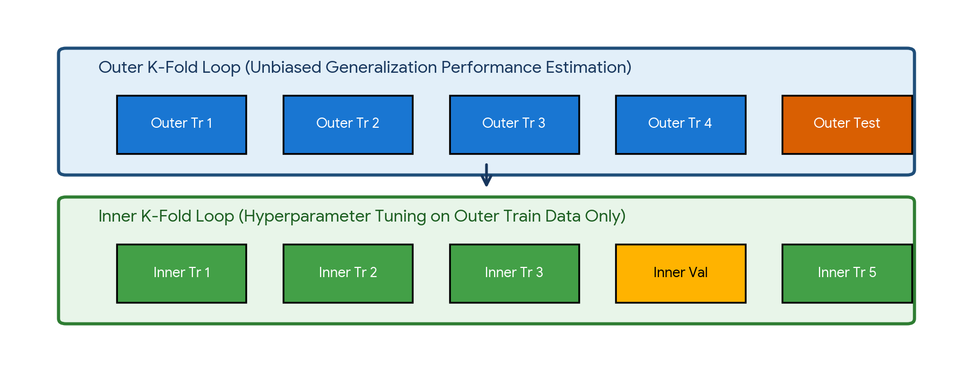
Figure 3. Architecture of Nested Cross-Validation separating unbiased model evaluation (outer loop) from hyperparameter tuning (inner loop).

The Mathematics of Nested Cross-Validation
When hyperparameter optimization (e.g., GridSearchCV) is conducted on a standard K-Fold CV, the reported validation score is biased because the hyperparameters were selected specifically to maximize performance on those folds. Nested Cross-Validation eliminates this optimization bias:
- Outer Loop: Partitions data into K_outer folds to evaluate unbiased model generalization error.
- Inner Loop: For each outer training fold, partitions data into K_inner folds to perform hyperparameter tuning and model selection.
- Result: The outer test folds are completely isolated from both parameter estimation and hyperparameter selection.

6. Hyperparameter Optimization Strategies
Model parameters (weights w, biases b, decision tree thresholds) are learned directly from training data via optimization algorithms. Model hyperparameters (learning rate, tree depth, regularization strength λ) must be specified prior to training and dictate how the model learns.
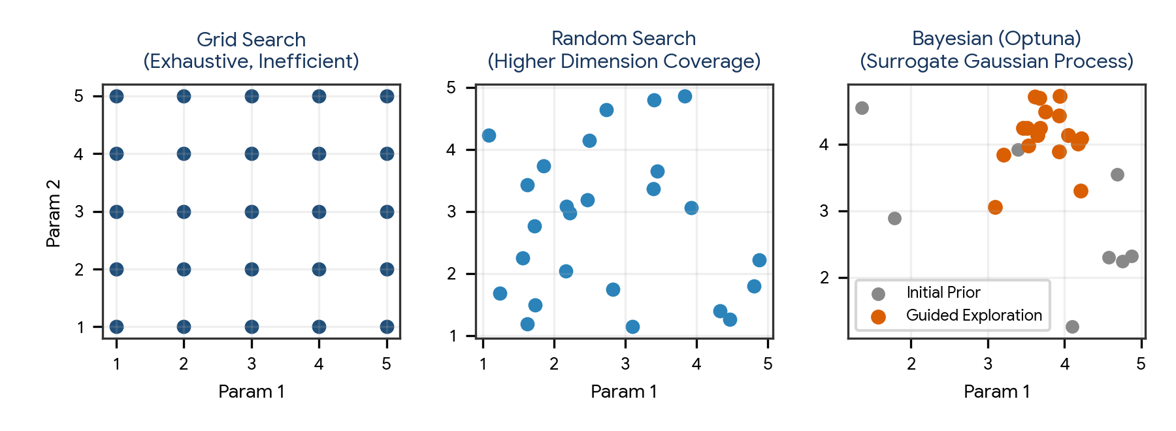
Figure 4. Comparison of hyperparameter search spaces: Grid Search (exhaustive), Random Search (high-dimensional efficiency), and Bayesian Optimization (guided exploration).
Optimization Strategy | Sampling Mechanism | Computational Cost | Key Advantages & Tradeoffs
Grid Search (GridSearchCV) | Exhaustive evaluation across a pre-defined Cartesian grid of discrete values | Extremely High: O( ∏ |S_i| ) combinations | Guarantees finding best combination on the grid; highly inefficient in high dimensions where only a few hyperparameters truly matter
Random Search (RandomizedSearchCV) | Samples fixed number of parameter configurations randomly from continuous distributions | Controlled: Fixed computational budget n_iter | Proven mathematically superior to Grid Search for high dimensions (Bergstra & Bengio, 2012); explores far more distinct parameter values
Bayesian Optimization (Optuna / Hyperopt) | Sequential model-based optimization using Gaussian Processes or Tree-structured Parzen Estimators (TPE) | Extremely Efficient: Concentrates trials in promising regions | Balances exploration of unknown spaces with exploitation of historical best scores; ideal for expensive models (e.g., XGBoost, Deep Nets)
Successive Halving / Hyperband | Allocates small resources (epochs/subsamples) to many candidates, progressively promoting the top 50% | Low to Moderate: Drastically slashes training time | Early stops unpromising configurations rapidly; implemented via HalvingGridSearchCV

7. Feature Importance & Model Interpretability
Understanding which features drive model predictions is essential for auditing algorithmic fairness, verifying domain causality, debugging data leakage, and satisfying regulatory compliance (e.g., GDPR Right to Explanation).
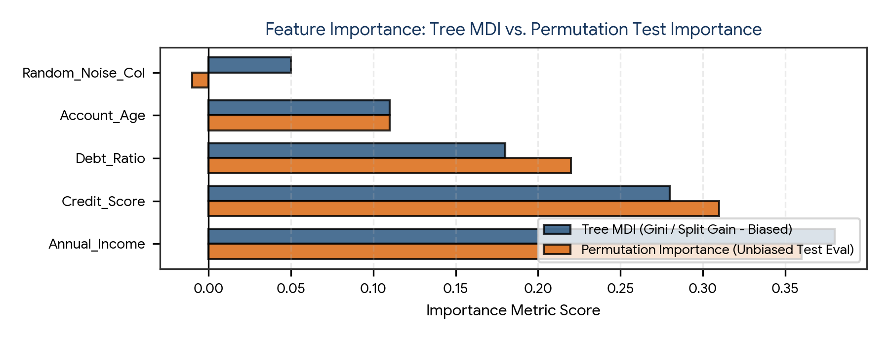
Figure 5. Feature importance comparison: Impurity-based MDI (biased toward high cardinality) vs. Permutation Importance (unbiased test evaluation).
Interpretability Method | Mathematical Basis | Evaluation Data | Strengths & Failure Modes
Tree MDI (Mean Decrease in Impurity) | Total reduction in Gini or Entropy brought by that feature, summed across all tree splits | Training Data | Computed automatically for free; severely biased toward continuous features and high-cardinality nominals; inflates random noise
Permutation Feature Importance | Shuffle values of feature j in validation set; measure drop in model performance metric | Validation / Test Data | Model-agnostic; reflects true generalization value; breaks if features are collinear (permuting one collinear feature has little impact)
SHAP (SHapley Additive exPlanations) | Cooperative game theory: computes marginal contribution of feature j across all possible feature subsets | Local & Global | Mathematically rigorous; guarantees local accuracy and consistency; TreeSHAP is fast, but KernelSHAP is computationally expensive
LIME (Local Interpretable Model-agnostic Explanations) | Fits a local sparse linear surrogate model in the immediate perturbation neighborhood of a specific instance | Local instance | Model-agnostic; intuitive local linear explanations; explanations can be unstable across slight perturbation seeds

8. Model Comparison & Statistical Significance Testing
In competitive benchmarking, deciding whether Model A is genuinely superior to Model B requires rigorous statistical testing. Observing a 0.5% higher test accuracy could simply be random sampling variance.
Statistical Test | Null Hypothesis (H₀) | Application in Model Selection
Paired Student's t-test | Mean performance difference across identical CV folds equals 0 | Comparing two regression or classification models evaluated on the exact same K cross-validation splits
McNemar's Test | Both classification models have identical disagreement rates on test samples | Contingency table test of binary predictions: compares cases where Model A is right and Model B is wrong
Wilcoxon Signed-Rank Test | Median performance difference across folds or datasets equals 0 | Non-parametric alternative to paired t-test when metric differences violate normality assumptions
5x2cv Paired t-test | Mean error difference across 5 repetitions of 2-fold CV equals 0 | Dietterich's standard benchmark test: eliminates fold overlap bias present in standard K-Fold t-tests

9. Practical Project — Enterprise Credit Risk Benchmarking Pipeline
Objective: design, build, and benchmark an end-to-end, object-oriented advanced machine learning pipeline that ingests continuous and categorical credit customer records, encapsulates preprocessing via ColumnTransformer, executes hyperparameter tuning via RandomizedSearchCV, evaluates feature importances using Permutation Importance, and benchmarks Logistic Regression, Random Forest, and Gradient Boosting.

Project structure
advanced_ml_benchmark_project/
|
|-- data/
| |-- customer_credit.csv
|
|-- reports/
| |-- model_benchmark_report.csv
| |-- permutation_importance.png
|
|-- main.py
|-- requirements.txt

requirements.txt
numpy
pandas
scipy
scikit-learn
matplotlib
seaborn

Complete main.py
import os
import numpy as np
import pandas as pd
from sklearn.model_selection import train_test_split, StratifiedKFold, RandomizedSearchCV
from sklearn.compose import ColumnTransformer
from sklearn.pipeline import Pipeline
from sklearn.impute import SimpleImputer
from sklearn.preprocessing import StandardScaler, OneHotEncoder
from sklearn.linear_model import LogisticRegression
from sklearn.ensemble import RandomForestClassifier, GradientBoostingClassifier
from sklearn.inspection import permutation_importance
from sklearn.metrics import roc_auc_score, f1_score, accuracy_score
import matplotlib.pyplot as plt
import seaborn as sns

class AdvancedMLBenchmarkPipeline:
def __init__(self, n_samples=1500, random_state=42):
self.n_samples = n_samples
self.random_state = random_state
self.output_dir = "reports"
os.makedirs(self.output_dir, exist_ok=True)
self.data = None
self.preprocessor = None
self.models = {}
self.best_pipelines = {}
self.results = []

def generate_synthetic_credit_data(self):
print("=== STEP 1: INGESTING SYNTHETIC CREDIT DATASET ===")
np.random.seed(self.random_state)

income = np.random.exponential(45000, self.n_samples) + 20000
credit_score = np.random.normal(650, 75, self.n_samples).clip(300, 850)
debt_ratio = np.random.uniform(0.05, 0.65, self.n_samples)
age = np.random.normal(42, 12, self.n_samples).clip(18, 75)

# Categorical features
housing = np.random.choice(["Rent", "Own", "Mortgage"], size=self.n_samples, p=[0.4, 0.35, 0.25])
loan_purpose = np.random.choice(["Debt_Consolidation", "Education", "Business"], size=self.n_samples)

# Ground truth non-linear default probability
logit = (
- 0.00003 * income
- 0.008 * credit_score
+ 6.2 * debt_ratio
- 0.02 * age
+ (housing == "Rent") * 0.8
+ (loan_purpose == "Business") * 0.9
+ 2.8
)
prob = 1 / (1 + np.exp(-logit))
default_target = (np.random.uniform(0, 1, self.n_samples) < prob).astype(int)

self.data = pd.DataFrame({
"Annual_Income": income.round(2),
"Credit_Score": credit_score.round(0),
"Debt_Ratio": debt_ratio.round(3),
"Age": age.round(0),
"Housing": housing,
"Loan_Purpose": loan_purpose,
"Default_Target": default_target
})
print(f"Generated {self.data.shape[0]} rows. Default Rate: {self.data['Default_Target'].mean():.4f}")

def partition_data(self):
print("\n=== STEP 2: LEAKAGE-FREE STRATIFIED SPLIT (80% Train, 20% Test) ===")
X = self.data.drop(columns=["Default_Target"])
y = self.data["Default_Target"]

self.X_train, self.X_test, self.y_train, self.y_test = train_test_split(
X, y, test_size=0.20, random_state=self.random_state, stratify=y
)
print(f"X_train shape: {self.X_train.shape}, X_test shape: {self.X_test.shape}")

def build_preprocessing_pipeline(self):
print("\n=== STEP 3: CONSTRUCTING COLUMNTRANSFORMER PIPELINE ===")
numeric_features = ["Annual_Income", "Credit_Score", "Debt_Ratio", "Age"]
categorical_features = ["Housing", "Loan_Purpose"]

num_transformer = Pipeline([
("imputer", SimpleImputer(strategy="median")),
("scaler", StandardScaler())
])

cat_transformer = Pipeline([
("imputer", SimpleImputer(strategy="most_frequent")),
("onehot", OneHotEncoder(drop="first", handle_unknown="ignore"))
])

self.preprocessor = ColumnTransformer([
("num", num_transformer, numeric_features),
("cat", cat_transformer, categorical_features)
])
print("Preprocessing architecture established.")

def optimize_and_benchmark_models(self):
print("\n=== STEP 4: HYPERPARAMETER TUNING & BENCHMARKING ===")
cv = StratifiedKFold(n_splits=5, shuffle=True, random_state=self.random_state)

# Model 1: Regularized Logistic Regression (ElasticNet-style via L2)
pipe_lr = Pipeline([
("preprocessor", self.preprocessor),
("clf", LogisticRegression(class_weight="balanced", random_state=self.random_state))
])
params_lr = {
"clf__C": np.logspace(-2, 2, 20),
"clf__penalty": ["l2"]
}

# Model 2: Random Forest
pipe_rf = Pipeline([
("preprocessor", self.preprocessor),
("clf", RandomForestClassifier(class_weight="balanced", random_state=self.random_state))
])
params_rf = {
"clf__n_estimators": [50, 100, 200],
"clf__max_depth": [4, 6, 8, 12],
"clf__min_samples_split": [2, 5, 10]
}

# Model 3: Gradient Boosting
pipe_gb = Pipeline([
("preprocessor", self.preprocessor),
("clf", GradientBoostingClassifier(random_state=self.random_state))
])
params_gb = {
"clf__n_estimators": [50, 100, 150],
"clf__learning_rate": [0.01, 0.05, 0.1],
"clf__max_depth": [3, 4, 5]
}

configs = [
("Logistic Regression", pipe_lr, params_lr),
("Random Forest", pipe_rf, params_rf),
("Gradient Boosting", pipe_gb, params_gb)
]

for name, pipe, params in configs:
search = RandomizedSearchCV(
pipe, params, n_iter=8, cv=cv, scoring="roc_auc",
random_state=self.random_state, n_jobs=-1
)
search.fit(self.X_train, self.y_train)
best_model = search.best_estimator_
self.best_pipelines[name] = best_model

# Evaluate on holdout test set
y_pred = best_model.predict(self.X_test)
y_prob = best_model.predict_proba(self.X_test)[:, 1]

acc = accuracy_score(self.y_test, y_pred)
f1 = f1_score(self.y_test, y_pred)
auc = roc_auc_score(self.y_test, y_prob)

print(f"{name:22s} | Best CV ROC-AUC: {search.best_score_:.4f} | Test ROC-AUC: {auc:.4f} | Test F1: {f1:.4f}")
self.results.append({
"Model": name,
"Best_CV_ROC_AUC": round(search.best_score_, 4),
"Test_ROC_AUC": round(auc, 4),
"Test_F1_Score": round(f1, 4),
"Test_Accuracy": round(acc, 4)
})

results_df = pd.DataFrame(self.results)
results_df.to_csv(os.path.join(self.output_dir, "model_benchmark_report.csv"), index=False)
print(f"\nBenchmark report saved to: {self.output_dir}/model_benchmark_report.csv")

def evaluate_permutation_importance(self):
print("\n=== STEP 5: PERMUTATION FEATURE IMPORTANCE (GRADIENT BOOSTING) ===")
best_model = self.best_pipelines["Gradient Boosting"]

result = permutation_importance(
best_model, self.X_test, self.y_test, n_repeats=10,
random_state=self.random_state, scoring="roc_auc"
)

sorted_importances_idx = result.importances_mean.argsort()
features = self.X_test.columns[sorted_importances_idx]
importances = result.importances_mean[sorted_importances_idx]

fig, ax = plt.subplots(figsize=(8, 4.5))
ax.barh(features, importances, color="#1F4E79", edgecolor="black")
ax.set_title("Test Set Permutation Importance (Metric: ROC-AUC)", fontsize=11, fontweight="bold", pad=8)
ax.set_xlabel("Mean Decrease in ROC-AUC Score Upon Permutation")
ax.grid(axis="x", linestyle="--", alpha=0.3)
plt.tight_layout()
plt.savefig(os.path.join(self.output_dir, "permutation_importance.png"), dpi=300)
plt.close()
print(f"Permutation importance chart saved to: {self.output_dir}/permutation_importance.png")

def run(self):
self.generate_synthetic_credit_data()
self.partition_data()
self.build_preprocessing_pipeline()
self.optimize_and_benchmark_models()
self.evaluate_permutation_importance()
print("\nAdvanced ML benchmarking workflow executed successfully.")

if __name__ == "__main__":
pipeline = AdvancedMLBenchmarkPipeline()
pipeline.run()

Run the project
pip install -r requirements.txt
python main.py

Expected generated outputs
reports/
|-- model_benchmark_report.csv
|-- permutation_importance.png

Project notes: by fitting the ColumnTransformer strictly inside Scikit-Learn Pipelines during RandomizedSearchCV, cross-validation folds remain completely isolated from out-of-fold information, guaranteeing zero data leakage.

10. Common Mistakes & Anti-Patterns to Avoid in Advanced ML
- Executing cross-validation outside a Pipeline: Calling scaler.fit_transform(X) before cross_val_score leaks validation distribution properties, artificially inflating performance scores.
- Optimizing hyperparameters directly against the test set: Repeatedly tweaking hyperparameter configurations based on test set scores transforms the holdout test set into an indirect training set.
- Trusting Tree MDI importance on continuous/high-cardinality features: Gini impurity reduction automatically favors features with many unique values even if they are pure random noise.
- Applying standard K-Fold CV to time-dependent data: Shuffling time-series observations breaks temporal causality, allowing the algorithm to train on future knowledge to predict historical records.
- Ignoring group structures in multi-sample entities: Splitting multiple clinical records from the same patient across both training and validation sets causes severe entity memorization.
- Relying strictly on Grid Search for high-dimensional tuning: Grid search spends 90% of its computational budget evaluating uninfluential hyperparameter combinations; use Random Search or Optuna.
- Declaring model superiority based on negligible metric margins: Claiming Model A is better than Model B because its test accuracy is 85.2% vs 84.9% without conducting statistical significance testing.

11. Quick Revision — Key Differences
Comparison | First Concept | Second Concept
Pipeline vs ColumnTransformer | Sequentially chains transformers and a final estimator across all data | Applies separate transformers to designated subsets of columns (numeric vs categorical)
Grid Search vs Random Search | Exhaustive evaluation of fixed grid; slow; poor for high dimensions | Samples random parameter points from continuous distributions; computationally superior
MDI vs Permutation Importance | Computed in-sample during training via Gini drop; biased toward high cardinality | Computed out-of-sample on test data by shuffling feature columns; unbiased benchmark
L1 (Lasso) vs L2 (Ridge) | Diamond constraint; drives uninformative weights strictly to zero (feature selection) | Spherical constraint; continuously shrinks weights toward zero without setting them to zero
Standard K-Fold vs Nested CV | Single loop CV; yields slightly optimistic scores when tuning hyperparameters | Dual-loop CV; outer loop provides unbiased evaluation while inner loop tunes hyperparameters
Data Drift vs Concept Drift | Input feature distribution P(X) shifts over time while P(y|X) remains constant | Relationship between features and target P(y|X) changes over time

12. Important Formulas Cheat Sheet
Concept / Model | Mathematical Formulation / Notation
Expected Prediction Error | EPE(x) = Bias²[f̂(x)] + Var[f̂(x)] + σ²_noise
Bias Formulation | Bias[f̂(x)] = E[f̂(x)] − f(x)
Variance Formulation | Var[f̂(x)] = E[ (f̂(x) − E[f̂(x)])² ]
Ridge Loss (L2) | J(w) = Loss_OLS + λ ||w||₂² = (1/2n) ||y − Xw||² + λ Σ w_j²
Lasso Loss (L1) | J(w) = Loss_OLS + λ ||w||₁ = (1/2n) ||y − Xw||² + λ Σ |w_j|
ElasticNet Loss | J(w) = Loss_OLS + α [ r ||w||₁ + ((1−r)/2) ||w||₂² ]
Target Encoding Smoothed | S_c = [ n_c ȳ_c + m ȳ_global ] / [ n_c + m ]
Permutation Importance | I(f_j) = Metric(D_test) − Metric(D_test, feature_j shuffled)
Cyclical Time Encoding | x_sin = sin(2π t / T), x_cos = cos(2π t / T)

13. Interview / Viva Questions
What is data leakage and how does a Scikit-Learn Pipeline prevent it?
Data leakage occurs when information from validation or test datasets contaminates model training. A Pipeline prevents it by ensuring all transformation parameters (like mean, median, or scale) are fit strictly on training folds and only applied to transform validation/test folds.
What is the difference between Pipeline and ColumnTransformer?
Pipeline executes a sequential chain of transformers ending with an optional estimator on a single feature matrix; ColumnTransformer applies different transformers in parallel to specified subsets of columns (e.g., numeric vs categorical) and concatenates the results.
Explain the Bias-Variance tradeoff.
Model error decomposes into Bias² (underfitting from overly simplistic assumptions), Variance (overfitting from excessive sensitivity to training noise), and Irreducible error (inherent noise). Increasing model complexity reduces bias but increases variance; optimal generalization lies at the minimum total error point.
Why is feature scaling mandatory before fitting L1 or L2 regularization?
Regularization adds a penalty proportional to weight magnitudes (λ Σ w² or λ Σ |w|). Unscaled features with large ranges naturally have tiny weights, unfairly escaping regularization, while small-scale features are penalized severely.
How does Lasso perform automated feature selection while Ridge does not?
Geometrically, Lasso's L1 constraint boundary is a diamond with sharp corners situated on the parameter axes. The elliptical OLS loss contours frequently intersect these sharp corners, driving coefficients exactly to zero. Ridge's L2 circle has no corners, so weights approach zero but never reach it.
When should you choose ElasticNet over Lasso?
When the dataset has multiple mutually correlated features (multicollinearity) or when the number of features exceeds the number of samples (d > n). Lasso arbitrarily selects one correlated feature, while ElasticNet selects groups of correlated features.
What is Nested Cross-Validation and why is it necessary?
Nested CV uses an inner loop for hyperparameter tuning and an outer loop for unbiased model evaluation. It is necessary because tuning hyperparameters on standard CV yields an overoptimistic evaluation score due to optimization bias.
Why is Random Search mathematically superior to Grid Search in high dimensions?
In high-dimensional spaces, only a small subset of hyperparameters significantly affects model performance. Grid search wastes trials testing combinations along uninfluential dimensions, whereas Random Search explores far more distinct values along every dimension.
How does Bayesian Optimization (e.g., Optuna) work?
It builds a probabilistic surrogate model (such as a Gaussian Process or Tree-structured Parzen Estimator) of the objective function, balancing exploration of uncertain regions with exploitation of known high-performing parameter spaces.
What is the difference between Tree MDI importance and Permutation Importance?
Tree MDI measures total impurity decrease (Gini/Entropy) during training and is heavily biased toward continuous or high-cardinality features. Permutation Importance evaluates the drop in model metric on unseen test data when a feature is shuffled, providing an unbiased estimate.
What are SHAP values and what theoretical guarantees do they provide?
SHAP values compute the marginal contribution of each feature across all possible feature subsets based on cooperative game theory (Shapley values). They provide mathematical guarantees of local accuracy, missingness, and consistency.
When should you use Group K-Fold instead of Stratified K-Fold?
When multiple rows in the dataset belong to the same underlying entity (e.g., multiple patient visits or user sessions). Group K-Fold ensures that an entire group remains within either train or validation, preventing entity memorization.
Why is standard cross-validation invalid for Time-Series data?
Standard cross-validation shuffles data, allowing models to train on future observations to predict historical records. TimeSeriesSplit uses expanding temporal windows, training strictly on past data.
What is target leakage and how can it be detected?
Target leakage occurs when an input feature includes information that is an artifact of the target outcome (e.g., 'Chemotherapy_Prescribed' predicting cancer). It is detected by auditing feature timelines and looking for suspicious correlations (|r| > 0.95).
What is cyclical feature encoding and when should it be used?
Transforming cyclical variables (hours 0–23, months 1–12) into sine and cosine pairs. It ensures that cyclical boundaries (hour 23 and hour 0) are recognized as geometrically adjacent.
What is the difference between Data Drift and Concept Drift?
Data drift is a shift in the input feature distribution P(X) over time while the target relationship remains constant; Concept drift is a shift in the mathematical relationship between features and target P(y|X).
Why is accuracy a deceptive metric for imbalanced classification?
In a dataset with 99% negative cases, a dummy model that always predicts negative achieves 99% accuracy while having zero recall on the positive class of interest.
How does McNemar's test evaluate model differences?
It analyzes a 2x2 contingency table comparing test instances where Model A was correct and Model B was wrong versus instances where Model B was correct and Model A was wrong.
What is the difference between Early Stopping and Regularization?
Regularization adds an algebraic penalty term to the loss function during optimization; Early stopping halts iterative gradient descent when validation loss stops improving, preventing overtraining.
What is an interaction feature?
A new feature created by multiplying or dividing two existing features (x_i × x_j), allowing linear models to capture multiplicative dependencies between variables.

14. Coding Practice
- Build an end-to-end Scikit-Learn Pipeline combining SimpleImputer, StandardScaler, and LogisticRegression.
- Construct a ColumnTransformer that applies median imputation and scaling to numerical features, and mode imputation with OneHotEncoder to categorical features.
- Implement a leak-free 5-fold cross-validation script using cross_val_score that encapsulates feature scaling inside a Pipeline.
- Demonstrate data leakage by standardizing a dataset before train_test_split vs inside a Pipeline, comparing the resulting test metrics.
- Write a Python script modeling cyclical temporal features (hours 0–23) using NumPy sin and cos transformations and plot them in a circle.
- Implement TargetEncoder from sklearn.preprocessing on a high-cardinality categorical feature and verify its smoothing behavior.
- Implement Nested Cross-Validation (5 outer folds, 3 inner folds) to tune a Random Forest classifier and output unbiased test scores.
- Configure and execute a RandomizedSearchCV optimization pipeline tuning max_depth, n_estimators, and learning_rate for GradientBoostingClassifier.
- Extract and contrast both Tree MDI feature importances and Permutation Feature Importances on a holdout test dataset.
- Implement a GroupKFold cross-validation workflow on a simulated multi-record patient dataset to ensure patient isolation.
- Perform a paired Student's t-test comparing cross-validation scores between a Logistic Regression baseline and a Random Forest ensemble.
- Extend the Credit Risk Benchmarking practical project to export an interactive ROC and Precision-Recall curve comparison.

15. Day 394 Completion Checklist
- ☐ Understand the role of Scikit-Learn Pipelines and ColumnTransformers in eliminating data leakage.
- ☐ Engineer high-signal features including polynomial interactions, binning, and smoothed target encoding.
- ☐ Encode periodic cyclical features using sine and cosine trigonometry.
- ☐ Decompose generalization error into Bias², Variance, and Irreducible Noise.
- ☐ Apply L1 (Lasso), L2 (Ridge), and ElasticNet regularization with mandatory feature scaling.
- ☐ Implement Stratified K-Fold, Group K-Fold, TimeSeriesSplit, and Nested Cross-Validation.
- ☐ Master hyperparameter tuning via Grid Search, Random Search, and Bayesian Optimization (Optuna).
- ☐ Evaluate feature importances using Tree MDI, Permutation Importance, and SHAP values.
- ☐ Execute statistical significance testing (Paired t-test, McNemar's test) for model comparison.
- ☐ Build and run the practical Enterprise Credit Risk Benchmarking Pipeline project.
- ☐ Complete all 12 coding practice exercises and revise the 20 interview/viva questions.

16. Learning Outcomes
After completing this revision, you should be able to:
- Design, build, and deploy production-grade Scikit-Learn Pipelines that bundle preprocessing and modeling without data leakage.
- Engineer informative numerical, categorical, and temporal feature representations.
- Diagnose model underfitting vs overfitting and calibrate model complexity along the bias-variance curve.
- Select and execute appropriate cross-validation architectures based on dataset dependencies (imbalance, groups, time-series).
- Optimize high-dimensional hyperparameter spaces efficiently using Randomized Search and Bayesian methods.
- Audit and explain model decision drivers using unbiased Permutation Importance and SHAP interpretability frameworks.
Next recommended topic: Day 395 — Deep Learning Foundations: Artificial Neural Networks (ANN), Forward Propagation, Activation Functions, Loss Functions, Backpropagation, and Gradient Descent Optimizers.

